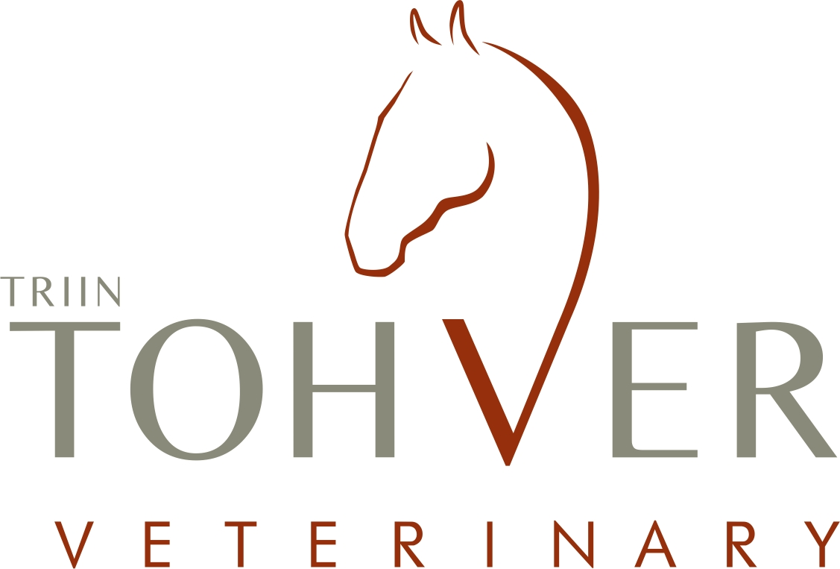

SERVICES
Here is a list of the standard equine veterinary services I offer. Please feel free to ask about any specific examinations and prices as every case is different and all services cannot be found in this list.
All prices include 20% income tax. Prices don´t include material and medication costs unless noted otherwise
GENERAL FEE and TRANSPORT €
- Homecall fee 15
only billed if no additional services are needed
- Transport fee 7
cost per one owner in all stables in and near Tallinn
- Transport fee in stables further than 50km from Kabila, Kernu 0,5/km
- Emergency call transport fee 0,66/km

EQUINE DENTISTRY
Routine oral examination and floating
- Thorough oral examination (with mouthgag and mirror) 16
- Short oral examination (without mouthgag) 6
- Floating of teeth, electic float (includes oral exam) 46

Treatment of paradontal disease

  - Diastema widening 24

Extraction of teeth in a standing horse

  - Extraction of wolf tooth (incl. local anaesthesia) 20
  - Extraction of incisors 24-60
  - Extraction of cheek teeth (premolars and molars) negotiated price
  - Trepanation and flushing of sinuses negotiated price
Sedation and local anaesthetic not included (ca.5-15€)

LAMENESS & DIAGNOSTIC IMAGING
Lameness exam

- Lameness exam, short (without nerve blocks) 24
- Lameness exam (with flexion tests and nerve blocks) 36
- Lameness exam, follow-up 12
- Neurologic exam 42
- Digital x-ray
  - one image (up to 3 images) 18
  - one image (4 and more images) 15
  - one image (Oxspring, skyline view, neck, back) 19

- Ultrasound exam 38
- Ultrasound exam, follow-up 24

Prices for nerve blocks and articular blocks will be added to the exam

- Nerve block 7,2
- Intraarticular block 35

Sedation and local anaesthetic not included (ca.1-15€)

Orthopedic treatments

- Intraarticular injection 30
- Injection of the navicular bursa 60
With x-ray guidance in the large animal clinic of the Agricultural University in Tartu
- Injection of ligaments and tendons with ultrasound guidance 40
- Local injection therapy (e.g stifle ligaments) 22,2
- Back injections 35
Medication not included (ca.5-60€)

Other lameness related services

- Bandage, regular 3,6
- Bandage, multiple layers 7,2
- Hoof bandage 8,4
- Cast 48
- Local intravenous perfusion of antibiotics 48

PRE-PURCHASE EXAM
- General check-up with flexion tests, no written report 48
- General check-up with flexion tests, written report or insurance papers 70

Radiography
- 10 x-ray images 145
- 12 x-ray images 168
- 14 x-ray images 189
- 16 x-ray images 208
- 18 x-ray images 225
- 18+ images, every additional image 12
- Written x-ray report (incl. sent x-ray images) 20
Ultrasound examination of the superficial digital and deep digital flexor tendon
  - 1 leg 36
  - 2 legs 44
  - 3 legs 72
  - 4 legs 80

CHIROPRACTIC EXAM
  - Chiropractic exam and treatment, horse 60
  - Chiropractic exam and treatment, small animal 30

GENERAL MEDICINE

General examination

- General examination and consultation (heart, lungs) 22
- Short consultation (e.g drug prescription) 6

Laborotory sampling

- Blood collection and interpretation of results 24
- Feces/urine sample 9,6
- Skin scraping 12
- Biopsy 30
Lab costs not included

- Skin biopsy for Lyme disease 110
Includes: sampling, sedation, materials, Böse lab costs, postal fee

Vaccines and deworming

- Vaccination, up to 3 horses 15
- Vaccination, more than 3 horses 5
- Deworming, up to 3 horses 6
- Deworming, more than 3 horses 4
Vaccines and dewormers not included in price

Other services

  - Passport markings 18
  - Flushing of tear duct 18
  - Local anaesthesia 12-20
  - Surgical opening of abszess/hematoma 24-36
  - Surgical removal of a skin tumor 30-54
  - Intravenous injection 8,4
  - Intramuscular/subcutaneous injection 4,8
  - Placement of a venous catheter 18

PULMONARY DISEASE

- Bronchoalveolar lavage (BAL) 85
Includes: sampling, sedation, laborotory costs

- Transtracheal wash 110
Includes: sampling, sedation, materials, Laboklin laborotory costs, postal fee

- Treatment plan, compilation and materials 12
Medication not icluded

GYNECOLOGY

- Ultrasound exam (evaluation of reproduvtive organs, pregnancy check) 20
- Intrauterine treatment 15-20
- Caslick surgery 30
- Removal of retained placenta 20-30

NUTRITIONAL CONSULTATION

- Composing of a feed plan (based on hay analysis) 20
- Feed or silage analysis 25

COMPETITION VET FEES

- 8h competition day 80
- Extra working hour (9 and more hours) 10

EMERGENCY SERVICES

- Emergency fee, 8.00-19.00 18
- Emergency fee, 19.00-07.00 and Sundays/holidays 45
- Intensive care, 1h 24-48

Colic, diagnostics and treatment

- General examination 22
- General and rectal examination 36
- Rectal exam, follow-up 18
- Nasogastric tube 25
- Removal of an osoephagus impaction 25-60

Wounds and injuries

- Wound debridement 8-18
- Suturing of wound 30-60
- Removal of wound sutures 12
- Joint flush with needles 60

Medication and material cost not included

Triin Tohveri Hoburavi has the right to change the prices without prior notice

July, 2018

